Batch: A3 Roll No.: 1911034

Experiment / assignment / tutorial No._____3__

Grade: AA / AB / BB / BC / CC / CD /DD

Signature of the Staff In-charge with date

TITLE: To find the values of the sin(x) , cos(x) and tan(x) using Modules and Packages

AIM: To learn about the concepts and implementation of Modules and Packages in python
______________________________________________________________________
Expected OUTCOME of Experiment:

CO - 2
_____________________________________________________________________
Books/ Journals/ Websites referred:

- Stackoverflow.com
- TutorialsPoint.com
- Geeksforgeeks.com
- Ma’am’s powerpoint.
_____________________________________________________________________
Pre Lab/ Prior Concepts:

Packages in python
As our application program grows larger in size with a lot of modules, we place similar modules in one package and different modules in different packages. This makes a project (program) easy to manage and conceptually clear.
Similarly, as a directory can contain subdirectories and files, a Python package can have sub-packages and modules.
A directory must contain a file named __init__.py in order for Python to consider it as a package. This file can be left empty but we generally place the initialization code for that package in this file.

We can import modules from packages using the dot (.) operator.

Modules in Python:
A module allows you to logically organize your Python code. Grouping related code into a module makes the code easier to understand and use. A module is a Python object with arbitrarily named attributes that you can bind and reference.
Simply, a module is a file consisting of Python code. A module can define functions, classes and variables. A module can also include runnable code.

Example
The Python code for a module named aname normally resides in a file named aname.py. Here's an example of a simple module, support.py
def print_func( par ):
print "Hello : ", par
return

Problem statement:
Create a package ‘myPackage’ which contains a class myMath. The class contains the following static methods.
i) power (x, y) – to compute x^{y}
ii) fact (x) – to compute x!
Write a program to find the following series.
cos (x),Sin(x), tan(x), (Do not make use of inbuilt functions. Use the functions of user defined class MyMath by importing mypackage.)
Similarly implement the same things using module (myModule)
A package is basically a distribution unit that can have one or more modules.

Program (with comments) (Write comments to your program to explain the implementation)

Program Implementation Using Packages :
Inside MyPackage Folder:

MyMath.py:

class MyMath:
@staticmethod
def power(x,y):
res = x**y
return res

@staticmethod
def fact(num): #this method computes the factorial recursively
factorial = 1

if num == 0:
return 1
else:
for i in range(1,num + 1):
factorial = factorial*i
return factorial

init.py

print("inside init")
import mypackage.MyMath #init is used to initialize the package

print("exiting init")

Outside MyPackage folder
mymain.py

import mypackage #the main function that imports the package should be outside the folder named mypackage and it should only contain import mypackage not import mypackage.filename

def mymain():
ch = int(input("enter your choice : 1 to find sin(x), 2 to find cos(x) and 3 to find the value of tan(x) "))
n = int(input("enter the number of terms "))
x = int(input("enter the angle in degrees "))
x = x*(3.142/180)
res1=0
res2=0
res3=0
#for the calculation of cos(x)
for i in range (1,n):
res1 = res1+ (mypackage.MyMath.MyMath.power(-1,(i-1))*mypackage.MyMath.MyMath.power(x,2*(i-1)))/mypackage.MyMath.MyMath.fact(2*(i-1))
#for the calculation of sin(x)
for i in range (1,n):
res2 = res2 + (mypackage.MyMath.MyMath.power(-1,(i-1))*mypackage.MyMath.MyMath.power(x,2*i-1))/mypackage.MyMath.MyMath.fact(2*i-1)
if ch==1:
print("The value of sin(x) is ", res2)
elif ch==2:
print("The value of cos(x) is ", res1)
elif ch==3:
res3=res2/res1
print("The value of tan(x) is ",res3)

mymain()

Output Screenshots:

Sin(x) value:
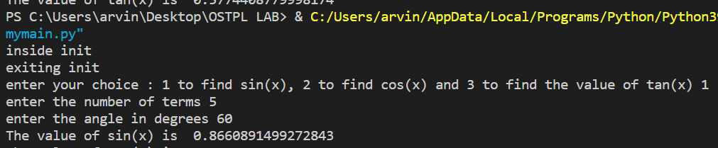

Cos(x) value :
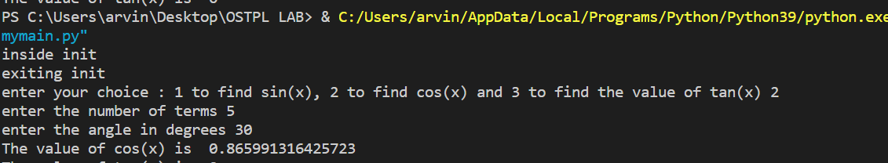

Tan(x) value :
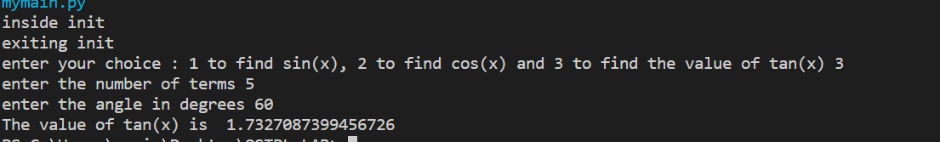

Python implementation using Modules :
Module MyModule.py
class MyMath:
@staticmethod
def power(x,y):
res = x**y
return res

@staticmethod
def fact(num): #this method computes the factorial recursively
factorial = 1

if num == 0:
return 1
else:
for i in range(1,num + 1):
factorial = factorial*i
return factorial

Module mymain.py
import MyModule

def mymain():
ch = int(input("enter your choice : 1 to find sin(x), 2 to find cos(x) and 3 to find the value of tan(x) "))
n = int(input("enter the number of terms "))
x = int(input("enter the angle in degrees "))
x = x*(3.142/180)
res1=0
res2=0
res3=0
#for the calculation of cos(x)
for i in range (1,n):
res1 = res1+ (MyModule.MyMath.power(-1,(i-1))*MyModule.MyMath.power(x,2*(i-1)))/MyModule.MyMath.fact(2*(i-1))
#for the calculation of sin(x)
for i in range (1,n):
res2 = res2 + (MyModule.MyMath.power(-1,(i-1))*MyModule.MyMath.power(x,2*i-1))/MyModule.MyMath.fact(2*i-1)
if ch==1:
print("The value of sin(x) is ", res2)
elif ch==2:
print("The value of cos(x) is ", res1)
elif ch==3:
res3=res2/res1
print("The value of tan(x) is ",res3)

mymain()

Output Screenshots:
Finding value of sin(x):
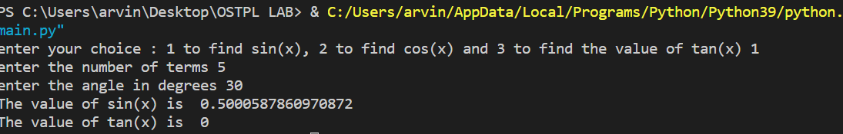
Finding value of cos(x):
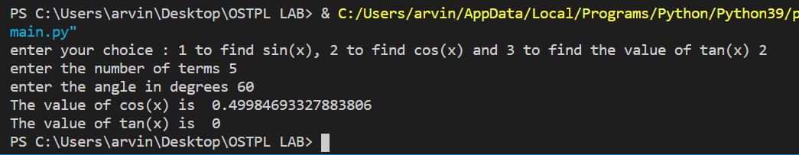
Finding value of tan(x)
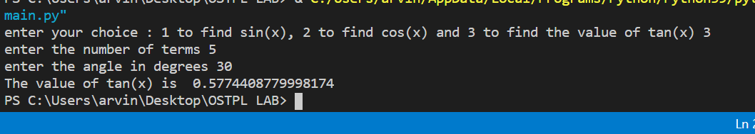

Conclusion: In this experiment we have learnt about and successfully applied the concepts of modules and packages to compute the sum of the series and find the values of sin(x) , cos(x) and tan(x)
Date: _____________ Signature of faculty in-charge

